Greetings!!!!!! The Kentucky Fillies Elite Track Club is an all girls Elite Club entering its 8th season! Our mission is to provide each athlete the opportunity to reach her full potential by developing athlete speed, endurance, and strength and fostering high self-esteem, self discipline, and goal achievement. We thank you for considering our track club and look forward to working with you. Please read this packet carefully so that you do not miss any important information.

Sign-Ups
Parents can sign up starting today by contacting Coach Townsend and completing the attached forms. You can respond by email to kyfilliestc@gmail.com or fill out the form on our website at kyfillies.com

There will also be sign-up opportunities March 25, 2019 thru May 15, 2019. Sign-ups are for girls between the ages of 7-17 years old eligible to compete in the AAU/USATF series. In addition, any youth who will still be 18 on August 4, 2019 is also eligible to compete in AAU/USATF series. Parents are asked to bring a copy of your youth’s birth certificate when you sign-up. Physicals are mandatory, especially if your child has a chronic medical condition like asthma, if she has not had a physical in the last 12 months she will need it before participating. By signing any documents, you are stating that you believe your youth to be healthy enough to participate.

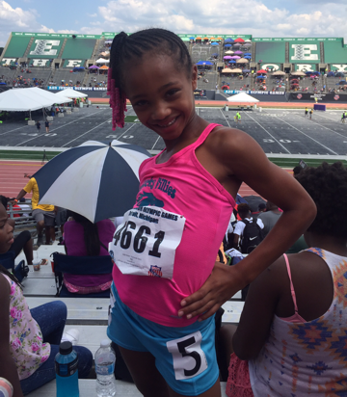
Try-outs
There will be a try-out for all athletes competing on this track team. There are no automatic spots. Try-outs will be May 15, 2019.

Practices
The first practice will be April 10, 2019 at Fairdale High School, which is located at 1001 Fairdale Rd, Fairdale, KY 40118 or at Ballard High School which is located at 6000 Brownsboro Road, Louisville, KY 40220. In general practices will be Mon, Tues, Thurs, and Friday from 6 - 8pm. Any changes to practice times and dates will be announced at practice or by text.
Parents must sign their youth in at the beginning of practice or let a coach know you have dropped her off. However, there are no parents allowed on the track during practice. Please address all issues and concerns with Coach Townsend either before or after practice. If you must leave, please make sure the coaching staff is aware. Finally, please make sure you return timely to pick up your child.
Weather wise, practices will be cancelled only if it is thundering and lightning. A gentle rain will not usually cancel practice. If you have questions or concerns about practice please call Coach Townsend (502)714-2645.

Cost
Cost of registration will be $150 for each girl. This covers the costs of required AAU and USATF memberships and administrative fees.
*Those that qualify for Nationals will incur additional costs to cover their transportation and hotel costs for the week; this will be discussed in more detail at a later date.

Payments
It would be wonderful to receive the full payment at the time of registration. However, we understand that for some this may pose a problem. Payment of at least half is due at registration. The remaining balance is due no later than May 30, 2019. If you think your youth will qualify for the Nationals, you are encouraged to ask about fundraising early.

Fundraisers
Know that it is illegal to use monies raised in the name of The Kentucky Fillies for anything other than Fillies activities.
All other fundraising ideas will be available during registration. Fundraising monies is allotted to the team not individual athletes.
All athletes are expected to participate in fundraising activities.
Volunteers: Adults are expected to volunteer to help with the millions of details that go on behind the scenes. Details done correctly contribute to a great program. If we pull together as a team and everyone does their part, this will make for less time over the course of the entire season.
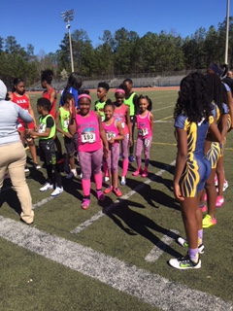

General Rules
- Ladies are expected to be Respectful at all times. No profanity will be tolerated. No cheating of any sort will be permitted. No use of drugs or alcohol will be permitted.
- Ladies are expected to attend all practices and obey the coaches. Ladies are expected to abide by any rules established for the common good or for individual enhancement. Practices are closed to parents and the public.
- Ladies are to compete in Kentucky Fillies uniform.
- Ladies are expected to give her BEST effort at all times. Your best may or may not be on the same level as your teammate, but should be YOUR best.
- Parents should not undermine the authority of the coaches/administrative staff. All concerns should be addressed first to the Head Coach or the Team Administrators. We will do our best to resolve any concerns or problems.
- Parents should make sure their youth are physically able to train, getting them to practice on time and picking up on time. Paying all fees timely and providing forms, birth certificates, and any other documentation as required. Parents should also make sure their child have appropriate clothing for training. (Note: Youth who run track in basketball shoes have an increased risk of injury. Tennis shoes and cross trainers are ok.)
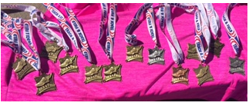
Kentucky Fillies Elite Track Club Checklist
- Birth Certificate (copy)
- Physical in the last 12 months
- Completed forms turned in (information sheet, rules/expectations, and waiver)

